June 5-9
Monday
Things we learned about: Books: The Doorbell Rang, How Will we get to the beach, Bounce
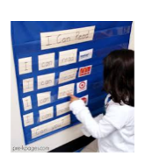
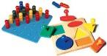
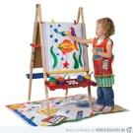
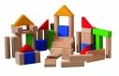
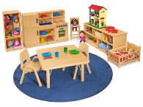
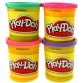
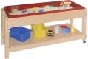
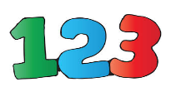
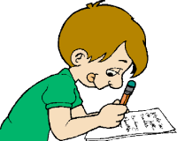
Listening
Pocket Chart
Manipulatives
Art
Blocks
Dramatic Play
Reading
Fine Motor
Sensory
Science
Math
Writing
Today, I played in these centers:

Parent Teacher Comments:

Tuesday

Things we learned about: Small Groups This Week: Alphabet Review, Writing CVC, numbers 1-10
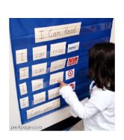
Listening
Pocket Chart
Today, I played in these centers:
Manipulatives
Art
Blocks
Dramatic Play
Reading
Fine Motor
Sensory
Science
Math
Writing

Parent Teacher Comments:

Wednesday
Things we learned about: Social This Week: How to say goodbye
Listening
Pocket Chart
Manipulatives
Art
Blocks
Dramatic Play
Reading
Fine Motor
Sensory
Science
Math
Writing

Today I, Played in these centers:

Parent Teacher Comments:

Thursday

Things we did:
Listening
Pocket Chart
Manipulatives
Art
Blocks
Dramatic Play
Reading
Fine Motor
Sensory
Science
Math
Writing
Today, I played in these centers:

Parent Teacher Comments Tomorrow is Field Day and the Last Day of School

